MENOFYIA UNIVERSITY  SYSTEM ANALYSIS & DESIGN PROJECT  SECOND YEAR  2026-2027 |  | جامعة المنوفية  كلية الحاسبات والمعلومات  2026-2027

Personal Document Expiration Reminder System
نظام تذكير بانتهاء صلاحية المستندات الشخصية

No. | Name | Section
1
2
3
4
5
6

Planning (Project Plan)

Project Identification
Project Name:
Personal Document Expiration Reminder System
Current Problem:
- People forget the expiry dates of their passports, national IDs, driving licences, residence permits, insurance cards and professional certificates.
- Document information is scattered across paper folders, phone notes, e-mails and memory, so nothing gives one clear picture.
- Late renewals cause fines, travel cancellations, delayed services and sometimes legal problems.
- There is no automatic, early and repeated warning, so users find out only when it is already too late.

Description about project:
- The Personal Document Expiration Reminder System is a web and mobile-friendly system where each user registers the personal documents he or she owns (type, number, issue date, expiry date, issuing authority) and optionally attaches a scanned copy.
- The system calculates the remaining time for every document and automatically sends reminders by e-mail, SMS and push notification at the intervals chosen by the user, for example 90, 60, 30, 14 and 7 days before expiry, and again on the expiry day.
- A dashboard shows all documents colour-coded as valid, expiring soon or expired. The user can search and filter documents, add family members' documents, record renewal requirements and mark a document as renewed so the next cycle starts automatically.
- An administrator manages users, document types, notification templates and reports, and can follow notification delivery status.

Task 1: System Request
System Request - Personal Document Expiration Reminder System
Project Sponsor: | Head of the Student Services Unit, Faculty of Computers and Information (sample sponsor - edit as needed)
Business Need: | 1. Reduce missed renewals and the fines that follow them.  2. Replace paper folders and scattered notes with one organised digital record.  3. Give every user early, repeated and automatic warnings.  4. Make document information available at any time and from any device.
Business Requirements: | 1- User registration and secure login.  2- Add, edit, delete and categorise personal documents with expiry dates.  3- Configurable reminders by e-mail, SMS and push notification.  4- Dashboard with status colours and a renewal calendar.  5- Admin panel, reports and notification log.  6- Family / dependants' documents under one account.
Business Value: | 1- Saving money by avoiding late-renewal fines.  2- Saving time and effort in searching for document details.  3- Peace of mind and fewer missed travel or service opportunities.  4- Possible revenue from premium plans and partner advertising.
Special Issues or Constraints: | 1- Delivery within 80 calendar days (first release on 06/01/2027).  2- Personal data must be protected (encryption, access control, privacy policy).  3- Reminders must be sent on time, so the scheduler must be reliable.  4- Limited student-team budget; free or low-cost tools are preferred.

Feasibility Study

Technical Feasibility
- The system can be built with standard web technologies: HTML, CSS and JavaScript for the front end, a server-side framework (for example Node.js or PHP/Laravel) and a relational database such as MySQL.
- Development tools are free and familiar to the team: Visual Studio Code, Git, StarUML and MySQL Workbench.
- A scheduled job (cron) checks expiry dates every day and triggers reminders; e-mail, SMS and push services are available through ready-made APIs.
- The system works on any device with a browser and an internet connection (Windows, Android, iOS), so no special operating system is required.
- Risk: dependence on third-party SMS/e-mail providers. Mitigation: support more than one channel and log delivery failures.

Economic Feasibility
All figures below are planning estimates in Egyptian pounds (EGP) and should be adjusted to your actual prices.
Item | Type | Cost (EGP)
Domain and hosting setup | One-time | 3,000
E-mail / SMS gateway setup | One-time | 2,000
Testing, security review and user training | One-time | 2,500
Development labour (student team, in-kind) | One-time | 0
Hosting and domain renewal | Yearly | 4,000
SMS credits | Yearly | 6,000
Maintenance and support | Yearly | 5,000
Total cost - Year 1 |  | 22,500

Expected benefit (Year 1) | Type | Value (EGP)
Late-renewal fines avoided by users | Tangible | 25,000
Premium subscriptions (about 500 users x 60 EGP) | Tangible | 30,000
Sponsored / partner advertising | Tangible | 5,000
Time saved, less stress, fewer missed opportunities | Intangible | Not measured
Total tangible benefit - Year 1 |  | 60,000

- Net benefit (Year 1) = 60,000 - 22,500 = 37,500 EGP
- ROI = 37,500 / 22,500 = about 167%
- Payback period = 22,500 / (60,000 / 12) = about 4.5 months
Conclusion: the project is economically feasible because the benefits clearly exceed the costs, and the main risk (a low number of paying users) does not stop the core free service.

Organizational Feasibility
- Management prowess: the project manager coordinates a team of analysts, designers and developers, and the faculty supervisor approves each phase.
- Resource sufficiency: human resources (6 team members), computers, internet access, a testing group of volunteer users, and a small hosting budget are available.
- User acceptance: in the Google Forms questionnaire, 4 of 6 respondents said they would definitely or probably use the system, so adoption risk is moderate to low.
- Legal and privacy: personal data is stored with consent, encrypted, and can be deleted at the user's request.

Task 2: Methodology
Selected methodology: Structured System Development Life Cycle (SDLC) with a prototyping step in the design phase.
The project follows the four classic SDLC phases, so every phase ends with clear deliverables that the supervisor can review. A working prototype of the dashboard and the reminder screens is shown to users before coding starts, to catch misunderstandings early.
Phase | Main activities | Deliverables
Planning | Identify the project, system request, feasibility study, time estimation, project plan | System request, feasibility report, PERT and Gantt charts
Analysis | Interviews, web questionnaire, study of the current process, define goals and requirements | Interview and questionnaire reports, current-state report, system goals
Design | DFDs, data dictionary, ER diagram, normalization, interface and notification design, prototype | Design documents, database schema, prototype
Implementation | Coding, testing, documentation, deployment, user training | Working system, test report, user guide

Why this methodology?
- The requirements are well understood (store documents, calculate expiry, send reminders), so a plan-driven approach fits.
- Each phase has a fixed deadline and deliverable, which matches the 80-day course schedule.
- The prototype step reduces the risk of building screens the users do not like.
- Documentation is produced at every phase, which is required by the course.

Time Estimation
The planning phase is used as the base: its actual duration is 12 days and it represents 15% of the project. The other phases are estimated from the standard percentages.
 | Planning | Analysis | Design | Implementation
Standard percentages | 15% | 20% | 35% | 30%
Estimated time based on planning time | Actual: 12 days | 16 days | 28 days | 24 days

- Total project time = 12 / 0.15 = 80 days.
- Analysis = 80 x 20% = 16 days; Design = 80 x 35% = 28 days; Implementation = 80 x 30% = 24 days.
- Dates: start 19/10/2026, expected finish 06/01/2027 (calendar days).

Case Study
Case: "Sara and the expired passport"
Sara is a 28-year-old accountant in Cairo who owns a passport, a national ID, a driving licence, a car licence, a health-insurance card and a professional certificate. She keeps the dates in different places: some in a phone note, some on paper, some only in her memory.

The problem
- Two days before an important business trip she discovers that her passport expires in less than six months, and the destination country refuses it. The trip is cancelled.
- Last year she also paid a fine because her driving licence expired without her noticing.
- Her father's residence-related documents and her sister's student ID have the same problem, and she is the person who is supposed to follow them.

How the system solves it
- Sara registers and adds each document once: type, number, issue date and expiry date. She adds her father's and sister's documents under "Family".
- The dashboard immediately shows that the passport is in red (expires within 90 days) and the licence is in orange.
- She selects reminders at 90, 60, 30, 14 and 7 days by push notification and e-mail, and an SMS on the last 7 days.
- Every morning the scheduler checks all dates; when a reminder is due, the notification service sends it and records it in the log.
- After renewing, Sara enters the new expiry date and marks the document as renewed; the reminder cycle restarts automatically.

Expected result
Sara is warned months before a deadline, the trip is not cancelled, and she no longer pays late fines. The same flow applies to every user, with the administrator monitoring users, templates and delivery reports.

Actors
Actor | Role
User | Registers, manages documents, sets reminder preferences, views dashboard.
Administrator | Manages users, document types, templates, reports and system settings.
Notification service | External e-mail / SMS / push providers that deliver the reminders.

Tasks Identification
ID | Task | Predecessor | Duration (days) | Start Date | End Date | Person assigned | Priority | Resources needed
A | System Request | - | 3 | 19/10/2026 | 21/10/2026 | Analyst 1 | High | MS Word
B | Feasibility Study | A | 5 | 22/10/2026 | 26/10/2026 | Analyst 2 | High | MS Word / Excel
C | Project Plan (Methodology, PERT, Gantt) | B | 4 | 27/10/2026 | 30/10/2026 | Project Manager | High | MS Project
D | Stakeholder Interviews | C | 6 | 31/10/2026 | 05/11/2026 | Analyst 1 | High | MS Word
E | Web Questionnaire (Google Forms) | C | 5 | 31/10/2026 | 04/11/2026 | Analyst 3 | Medium | Google Forms
F | Interview & Current-System Reports | D,E | 5 | 06/11/2026 | 10/11/2026 | Analyst 2 | High | MS Word
G | Requirements & System Goals | F | 5 | 11/11/2026 | 15/11/2026 | Analyst 1 | High | MS Word
H | Data Model: ER Diagram & Normalization | G | 8 | 16/11/2026 | 23/11/2026 | Designer 1 | High | StarUML
I | User Interface & Notification Design | G | 10 | 16/11/2026 | 25/11/2026 | Designer 2 | Medium | Figma / Draw.io
J | Database & Architecture Design | H | 10 | 24/11/2026 | 03/12/2026 | Designer 1 | High | MySQL Workbench
K | Prototype & Design Review | I,J | 10 | 04/12/2026 | 13/12/2026 | Team | High | Visual Studio Code
L | Coding | K | 14 | 14/12/2026 | 27/12/2026 | Developers | High | Visual Studio Code
O | Documentation & User Guide | K | 10 | 14/12/2026 | 23/12/2026 | Analyst 3 | Low | MS Word
M | Testing | L | 7 | 28/12/2026 | 03/01/2027 | Tester | High | Test tools
N | Deployment & Training | M,O | 3 | 04/01/2027 | 06/01/2027 | Team | High | Cloud hosting

Team roles (Analyst 1-3, Designer 1-2, Developers, Tester, Project Manager) are placeholders: replace them with the real names of your team members. Dates use calendar days starting on 19/10/2026.
Critical path: A - B - C - D - F - G - H - J - K - L - M - N = 80 days. Tasks with slack: E (1 day), I (8 days), O (11 days).

Pert Chart
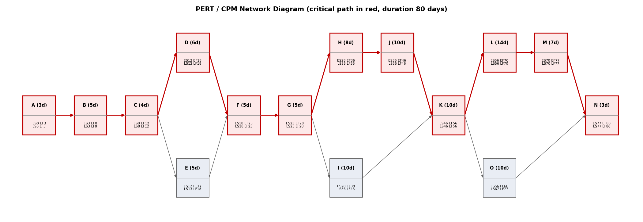
Each node shows the task ID and duration, ES/EF (earliest start/finish) and LS/LF (latest start/finish). Tasks with zero slack form the critical path (red).

CPM Schedule Table
ID | Task | Duration | ES | EF | LS | LF | Slack
A | System Request | 3 | 0 | 3 | 0 | 3 | 0
B | Feasibility Study | 5 | 3 | 8 | 3 | 8 | 0
C | Project Plan (Methodology, PERT, Gantt) | 4 | 8 | 12 | 8 | 12 | 0
D | Stakeholder Interviews | 6 | 12 | 18 | 12 | 18 | 0
E | Web Questionnaire (Google Forms) | 5 | 12 | 17 | 13 | 18 | 1
F | Interview & Current-System Reports | 5 | 18 | 23 | 18 | 23 | 0
G | Requirements & System Goals | 5 | 23 | 28 | 23 | 28 | 0
H | Data Model: ER Diagram & Normalization | 8 | 28 | 36 | 28 | 36 | 0
I | User Interface & Notification Design | 10 | 28 | 38 | 36 | 46 | 8
J | Database & Architecture Design | 10 | 36 | 46 | 36 | 46 | 0
K | Prototype & Design Review | 10 | 46 | 56 | 46 | 56 | 0
L | Coding | 14 | 56 | 70 | 56 | 70 | 0
O | Documentation & User Guide | 10 | 56 | 66 | 67 | 77 | 11
M | Testing | 7 | 70 | 77 | 70 | 77 | 0
N | Deployment & Training | 3 | 77 | 80 | 77 | 80 | 0

Gantt Chart
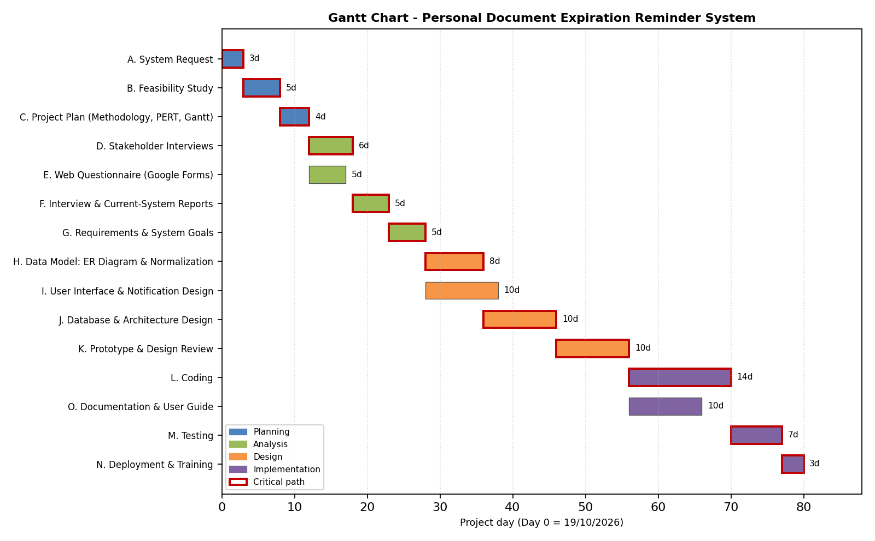

Analysis

Task 3: Questions and Answers
Twenty questions were prepared: 10 open-ended questions asked in face-to-face interviews, and 10 closed questions published as a web form. The interview answers are sample data prepared for this project (replace them with your real interview notes if you have them); the web form results in Section B are the real responses collected with Google Forms.
Interviewees: Mr. Omar Hassan (administrative officer who follows staff documents), Ms. Mona Adel (frequent traveller / freelancer), Eng. Youssef Samir (IT specialist). Interviewer: project analyst.

Section A: Open Questions - Interview (10 questions)
No. | Open question | Answer
1 | What is your opinion of the way you currently keep track of document expiry dates? | It is not good. I rely on memory and a few notes, so I always feel that something may be forgotten.
2 | Which personal documents do you manage, and which ones cause you the most trouble? | Passport, national ID, driving licence, car licence and insurance cards. The passport and driving licence cause the most trouble because renewing them takes time.
3 | Describe what happened the last time a document expired without you noticing. | My driving licence expired and I paid a fine and lost two days in queues. A passport problem also forced me to postpone a trip.
4 | How do you remember renewal dates now, and what tools do you use? | Phone calendar notes, a paper folder and sometimes photos of the documents. There is no single place and no automatic alert.
5 | What are the common errors or problems with the current method? | Dates are not written at all, notes are lost when the phone changes, and nobody warns early enough. Family members' documents are forgotten most.
6 | What are the critical objectives you expect from a reminder system? | Never miss a deadline, be easy to use, work on the phone, and keep my data private.
7 | What features would you like to add to the new system? | Several reminders per document, family accounts, a colour-coded dashboard, renewal checklists and a simple report of what expires this month.
8 | How and how early would you like to be notified? | Push notification and e-mail first, SMS when it is close. The first warning should be about two to three months before expiry for passports and one month for the rest.
9 | What concerns do you have about storing personal document data in a system? | Security. I only want to store the type and the expiry date, and I want the option to upload nothing else. Data should be encrypted and deletable.
10 | Is there anything else you would like to add? | Please make the system simple and fast, and allow Arabic and English.

Section B: Web Form Questions - Google Forms (10 questions, 6 responses)
The questionnaire was published with Google Forms and received 6 responses (some questions were answered by 5 respondents). Question 4 is a short-text question; the other nine are closed questions (choice or 1-5 scale). The screenshots of the form results follow the table.
No. | Question | Type | Responses | Results
1 | Do u prefer the system website or system application | Choice | 5 | Website: 2 (40%)  Application: 3 (60%)
2 | Is the system easy to use | Scale 1-5 | 5 | 1: 0 (0%)  2: 0 (0%)  3: 2 (40%)  4: 2 (40%)  5: 1 (20%)  Average: 3.8
3 | How important is it for you to have a simple and easy-to-use interface? | Scale 1-5 | 6 | 1: 0 (0%)  2: 0 (0%)  3: 1 (16.7%)  4: 2 (33.3%)  5: 3 (50%)  Average: 4.3
4 | What are the common mistakes in the system | Short text | 5 | Incorrect document information  Late reminder / missing notifications  Missing notifications  Poor user interface  Security and privacy issues
5 | When would you prefer to receive a reminder before a document expires? | Choice (days) | 6 | 7 days: 0 (0%)  15 days: 2 (33.3%)  30 days: 4 (66.7%)  60 days: 0 (0%)
6 | How useful do you think Personal Document Expiration Reminder System would be for you? | Scale 1-5 | 6 | 1: 0 (0%)  2: 2 (33.3%)  3: 2 (33.3%)  4: 1 (16.7%)  5: 1 (16.7%)  Average: 3.2
7 | Would you use this system to manage and track your personal documents? | Choice | 6 | Definitely: 1 (16.7%)  Probably: 3 (50%)  Not sure: 1 (16.7%)  Probably not: 1 (16.7%)  Definitely not: 0 (0%)
8 | What is your opinion on the system | Scale 1-5 | 5 | 1: 0 (0%)  2: 1 (20%)  3: 1 (20%)  4: 3 (60%)  5: 0 (0%)  Average: 3.4
9 | Which feature do you think is the most important in this system? | Choice | 6 | Expiration reminders: 1 (16.7%)  Saving document details: 1 (16.7%)  Calendar of expiration dates: 3 (50%)  Renewal history: 1 (16.7%)
10 | How would you prefer to receive expiration reminders? | Choice | 6 | Email: 2 (33.3%)  SMS: 1 (16.7%)  Mobile notifications: 3 (50%)  WhatsApp: 0 (0%)

Key findings
- Platform: 60% prefer a mobile application over a website (40%).
- Interest: 4 of 6 respondents (66.7%) would definitely or probably use the system; 1 is not sure and 1 probably would not.
- Interface: 5 of 6 (83.3%) rated a simple, easy-to-use interface 4 or 5 out of 5 (average 4.3), and the ease-of-use rating is 3.8 out of 5.
- Most important feature: the calendar of expiration dates (50%); the others got 16.7% each.
- Reminders: 66.7% want the first reminder 30 days before expiry, and mobile notifications (50%) then e-mail (33.3%) are the preferred channels.
- Common mistakes mentioned: missing or late notifications (2 answers), incorrect document information, poor user interface, and security and privacy issues.

Google Forms results (screenshots)
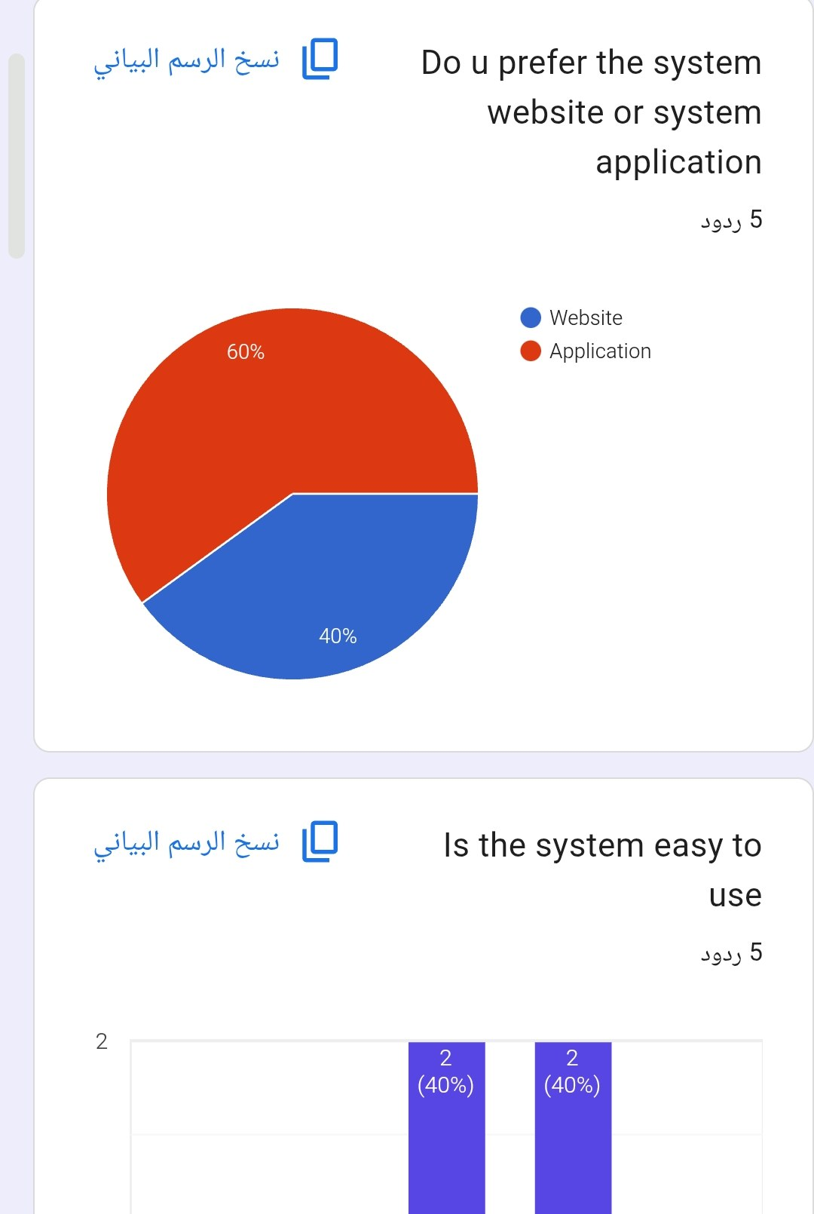 | 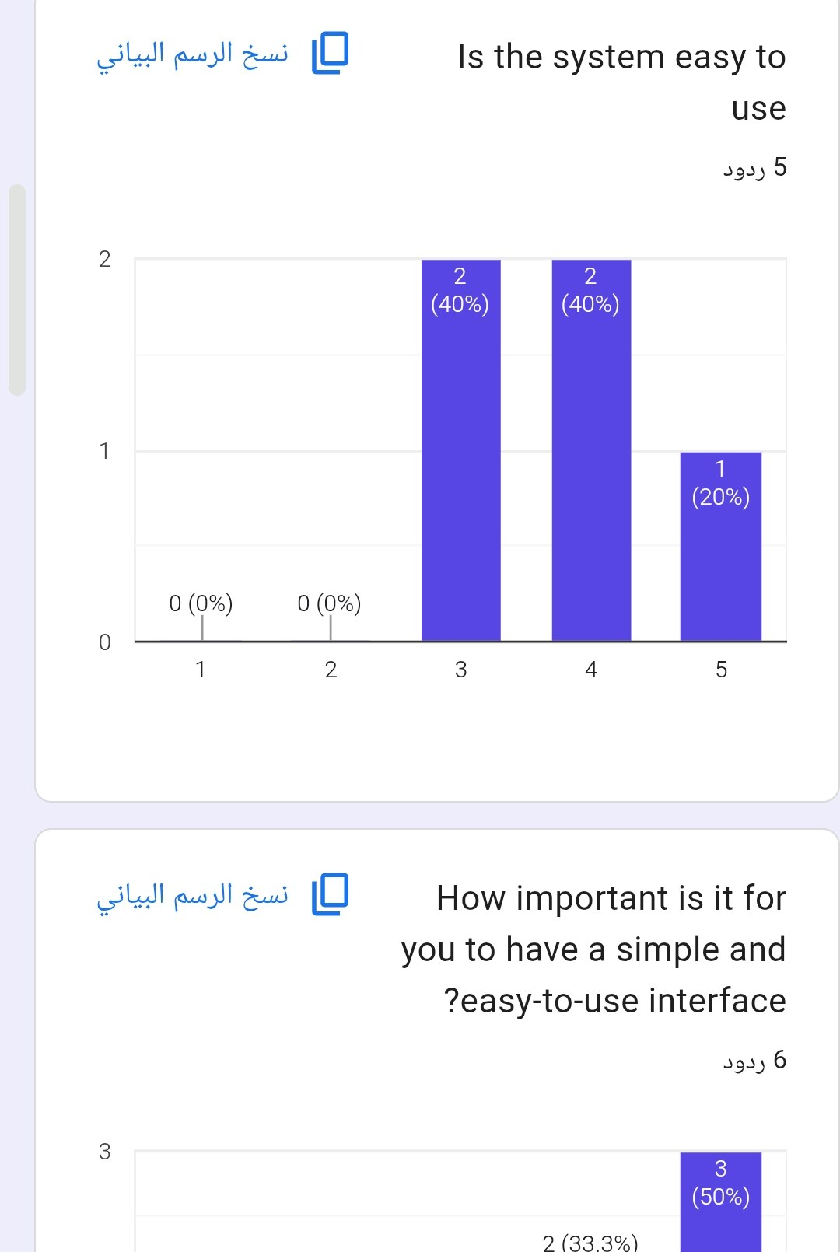
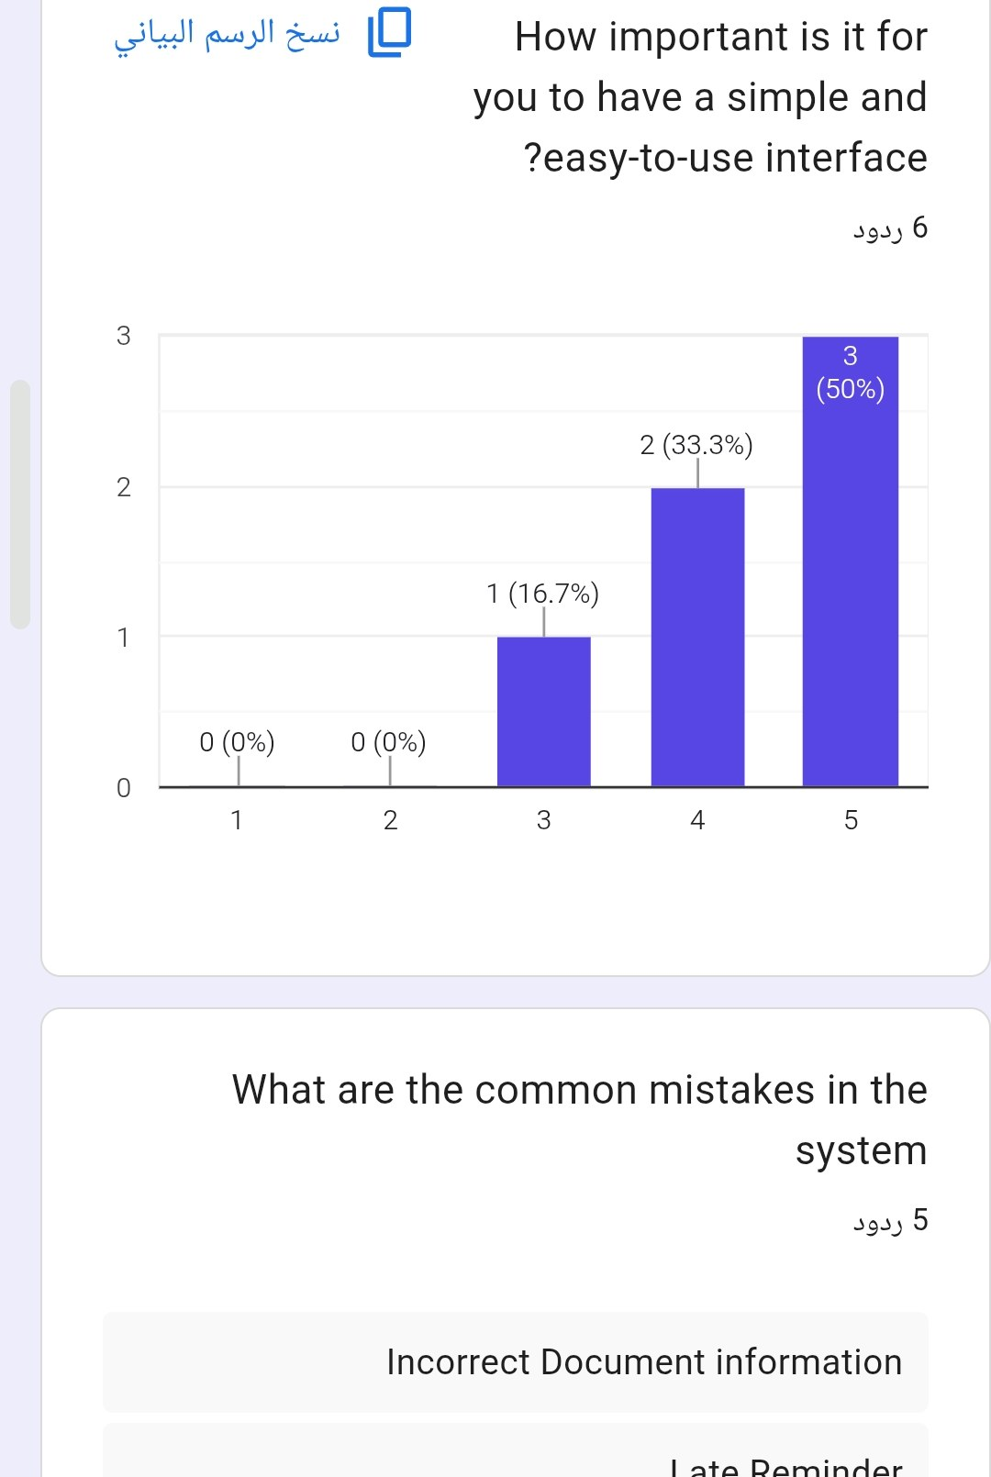 | 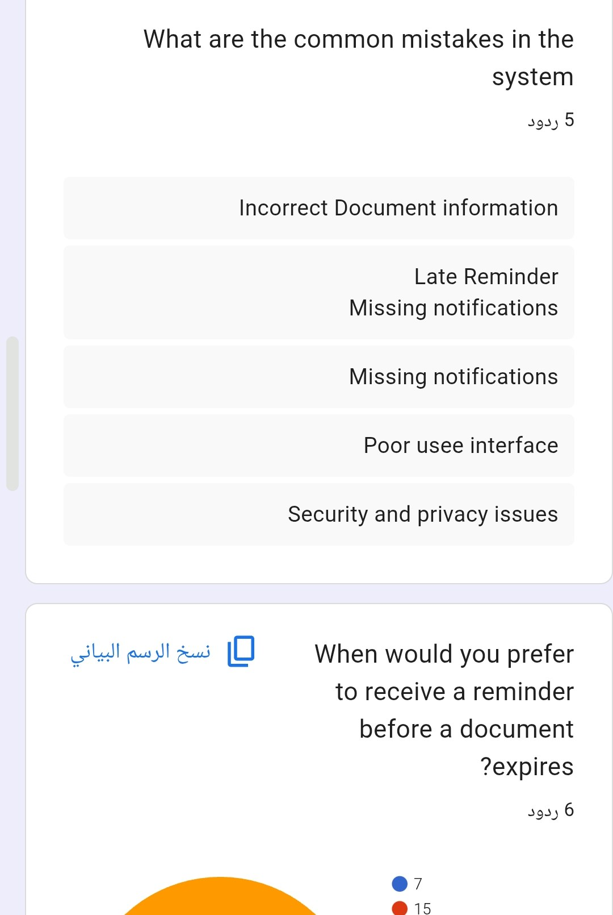

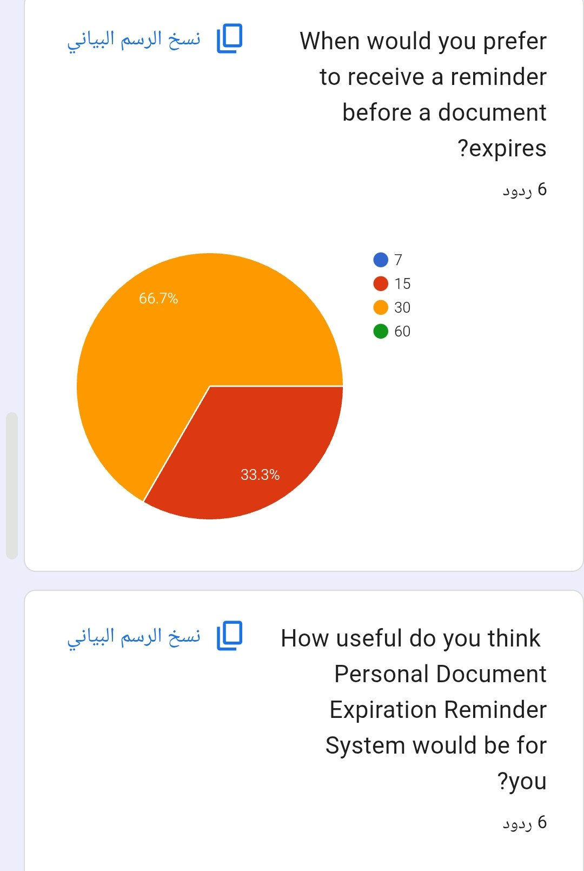 | 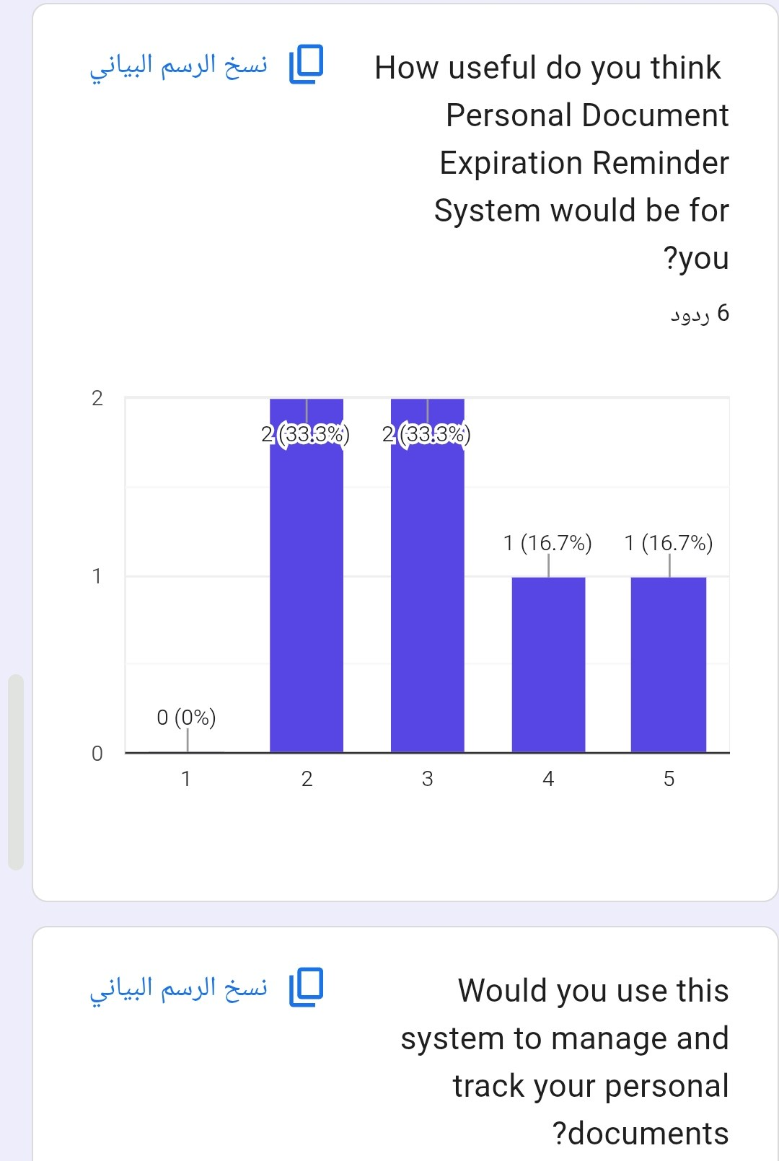
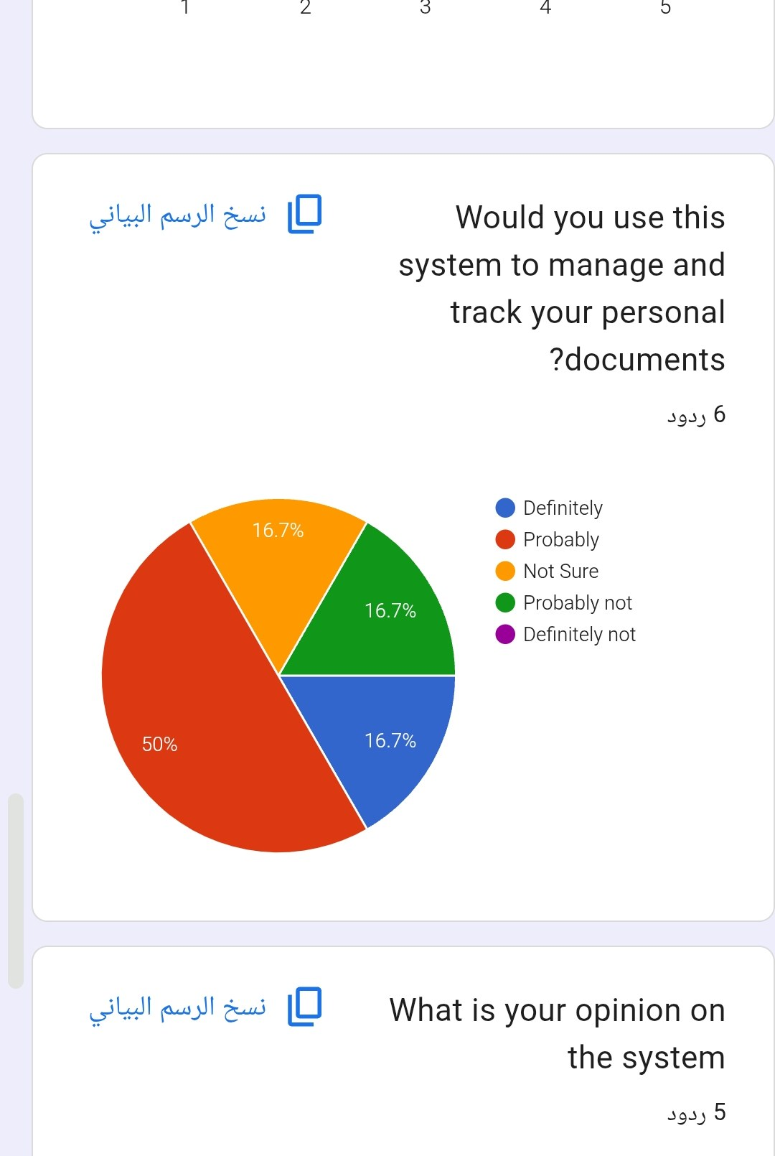 | 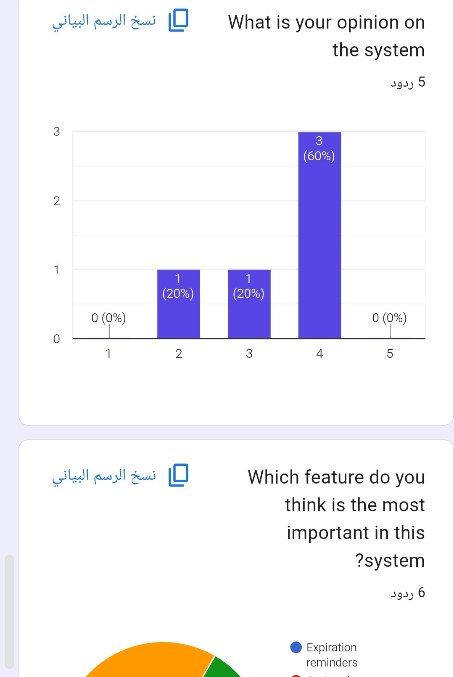

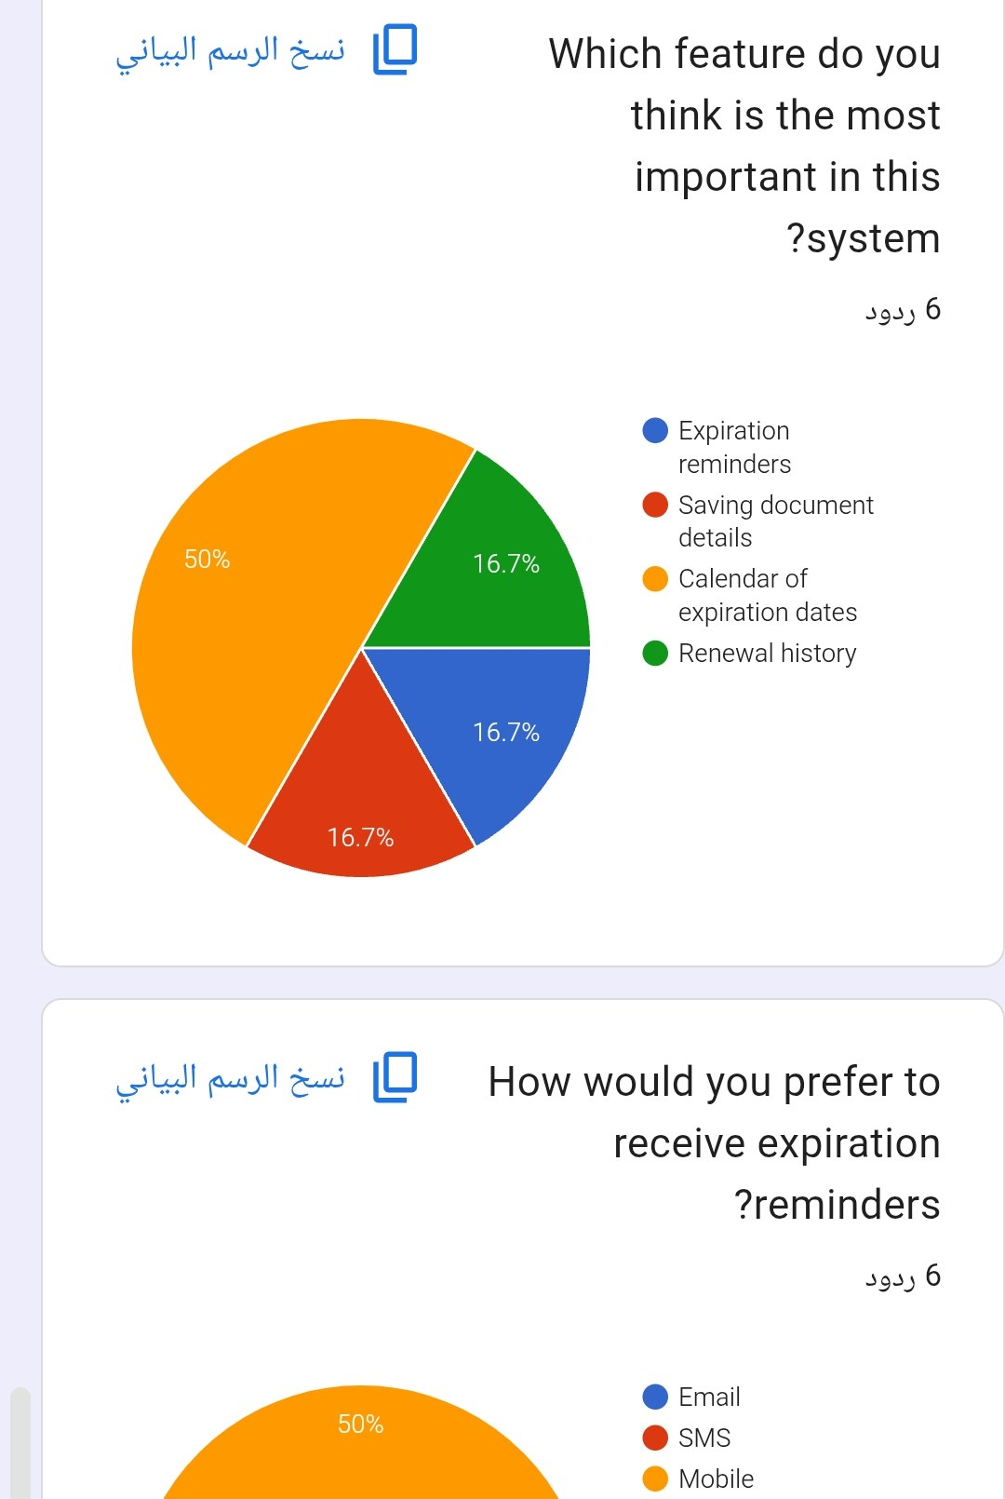 | 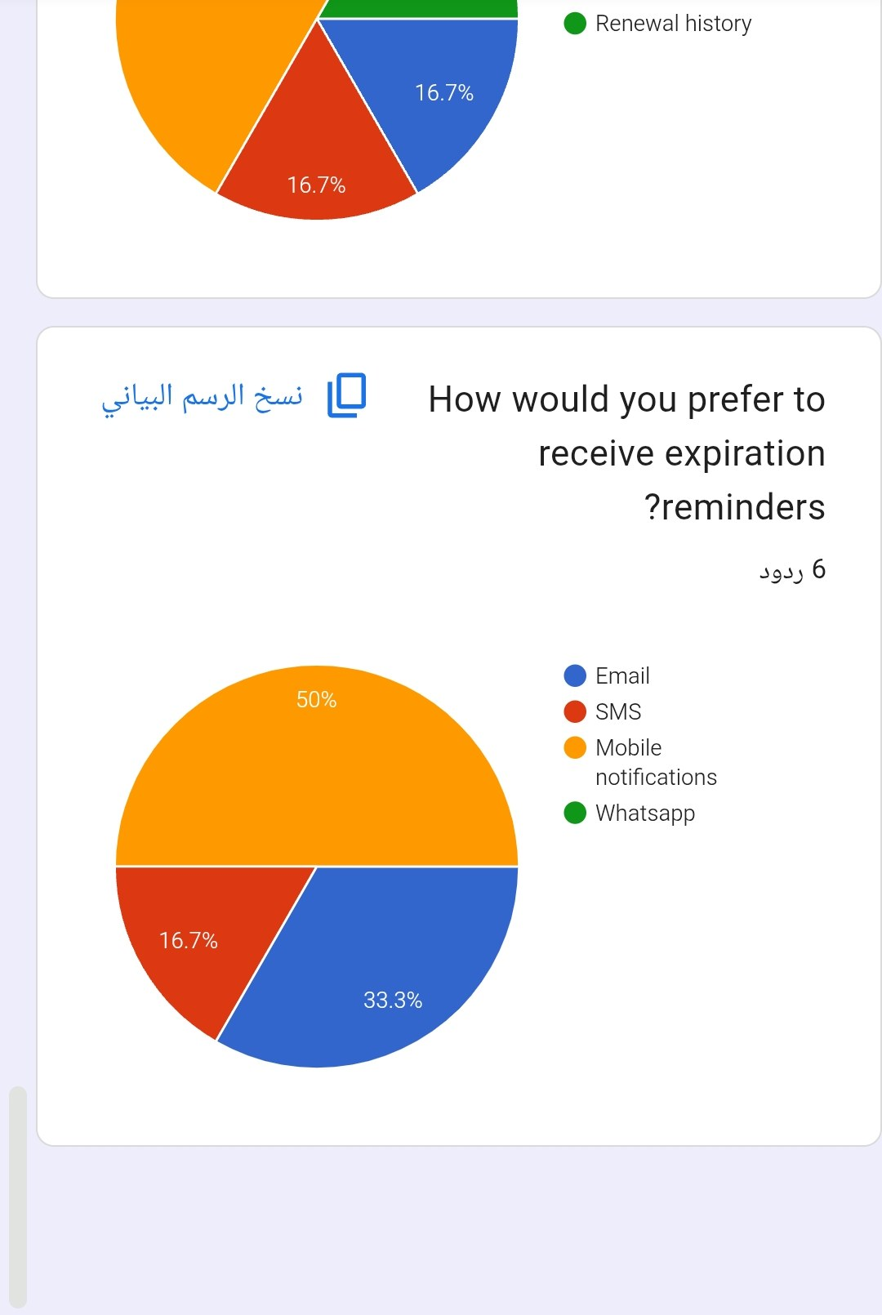

Interview Reports
Report 1: Interview Opinion
Interview Report - Opinion
Persons Interviewed: Mr. Omar Hassan, Ms. Mona Adel, Eng. Youssef Samir
Interviewer: Project analyst
Purpose of Interview:
- To understand how people track personal document expiry dates today
- To collect opinions about problems and desired improvements
- To learn which tools, channels and security measures the new system needs
Summary of Opinions:
- All three interviewees think the current method is weak because it depends on memory and scattered notes.
- They agree that automatic reminders sent early and more than once are the most valuable feature.
- They prefer push notification and e-mail, with SMS as a last warning.
- They want a simple dashboard, family accounts and Arabic/English support.
- Privacy is the main concern: store as little as possible and encrypt everything.
Open Items:
- Decide the default reminder schedule for each document type
- Define what the user can upload and how long the data is kept
- Choose the SMS and e-mail providers
Detailed Notes: See the question and answer table in Task 3.

Report 2: Interview Feelings
Interviewee | Observed feeling | What triggered it | Meaning for the system
Mr. Omar Hassan | Stress and pressure | Talking about colleagues who arrive at deadlines with expired papers | Needs clear reports and early alerts for many people
Ms. Mona Adel | Frustration and regret | Remembering the cancelled trip and the fine | Reminders must come early and repeat
Ms. Mona Adel | Optimism | Imagining one dashboard with all dates | Dashboard must be simple and visual
Eng. Youssef Samir | Caution / worry | Discussing storage of document data | Security and privacy must be visible to users
All three | Interest and relief | Hearing about automatic reminders | High chance of user acceptance
These feelings were observed from tone of voice, expressions and the words used during the interviews (sample observations).

Report 3: Current State of the System
Current State of the System
Description:
There is no dedicated system today. Each person tracks document expiry dates manually, using memory, phone notes or calendars, paper folders and photos of the documents.
Current methods:
- Phone calendar or notes: free and quick, but reminders are manual, often set once, and lost when the phone changes.
- Paper folders: complete documents, but dates are not visible and nothing warns the owner.
- Memory: no cost, but unreliable, especially for several documents and family members.
Problems:
- No single place for all documents
- No early or repeated warning
- Family members' documents are forgotten
- Fines, cancelled trips and wasted time
- Low security of paper copies and photos kept in phone galleries
Technologies used now:
- Phone calendar/notes, paper files, photo gallery - no connected system
Conclusion:
The current state is manual, scattered and reactive. A central system with automatic reminders is needed.

Report 4: System Goals
Goal type | Goal | How it is measured
Business | Reduce missed renewals and related fines | Fewer missed deadlines reported by users
Business | Save time and effort in tracking documents | Time to find a document date under 30 seconds
Functional | Store documents and their expiry dates for the user and family | Documents can be added, edited and deleted
Functional | Send reminders automatically by e-mail, SMS and push | At least 98% of reminders delivered on schedule
Functional | Show a colour-coded dashboard and renewal calendar | Status visible on the first screen
Functional | Provide admin management and reports | Users, templates and logs manageable by admin
Non-functional | Protect personal data (encryption, access control) | No unauthorised access in security testing
Non-functional | Be simple, fast and available in Arabic and English | Pages load in under 3 seconds; users finish tasks without help
Non-functional | Be available most of the time | Availability of 99% or more

Design

Data Flow Diagram - Context Diagram
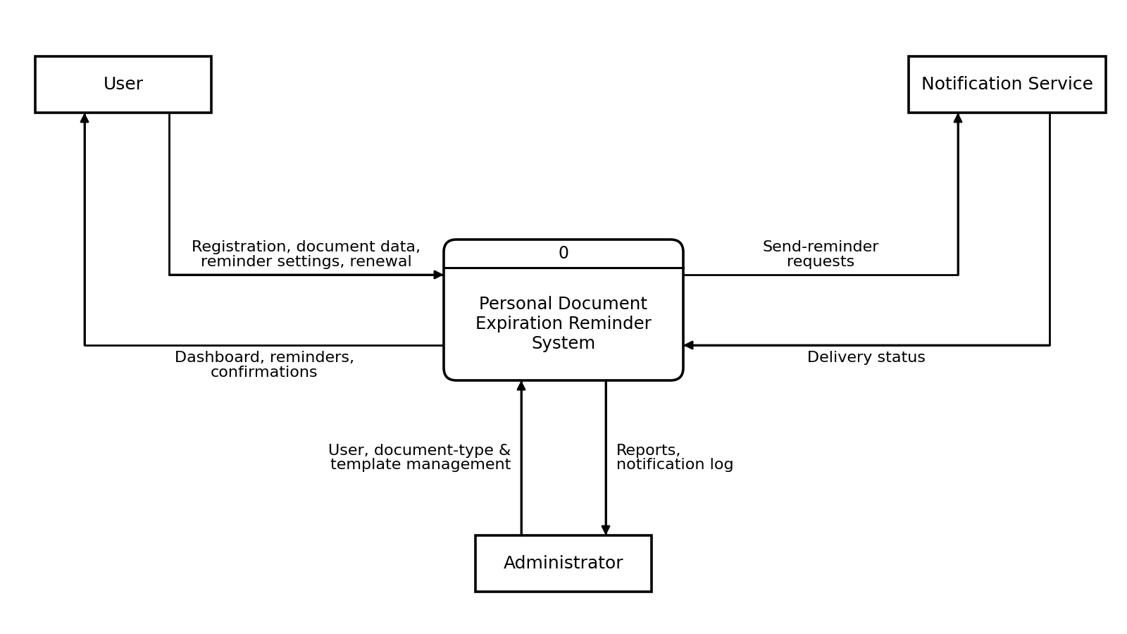
External entities: User, Administrator, Notification Service (E-mail / SMS / Push). Process 0: Personal Document Expiration Reminder System.

Data Flow Diagram - Level/Diagram 0
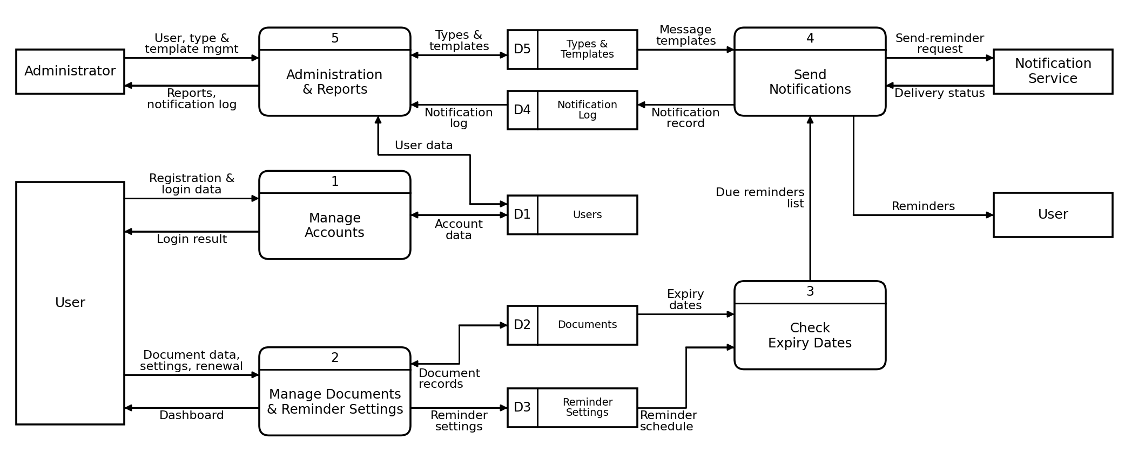
Processes: 1 Manage Accounts, 2 Manage Documents & Reminder Settings, 3 Check Expiry Dates, 4 Send Notifications, 5 Administration & Reports. Data stores: D1 Users, D2 Documents, D3 Reminder Settings, D4 Notification Log, D5 Document Types & Templates.

